(Approx. 632 words)

Windows 11 OneDrive and a Microsoft Account
An Offer You Can’t Refuse?
David Kretchmar, Hardware Technician, Sun City Summerlin Computer Club
https://www.scscc.club
dkretch (at) gmail.com

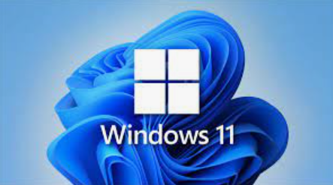
OneDrive is cloud storage that is built into the Windows 11 operating system. Microsoft has integrated OneDrive more closely into Windows 11 than Windows 10, presumably to get more users onboard with what OneDrive offers. In this article, I’m not going to get into the “nuts and bolts” of the operation of OneDrive in Windows 11 but discuss some advantages of using OneDrive, and hopefully convince users who have not taken advantage of this feature to consider it.

What is OneDrive, and why do I need it?

OneDrive is the Microsoft cloud service that allows you to access your files from any device connected to the internet. OneDrive enables you to store and protect your files, share them with others, and get to them from anywhere on any device. OneDrive can be used on many operating systems, including iOS or Android.

What’s in It for Microsoft?

OneDrive and Microsoft Office 365 can provide Microsoft with “recurring” or “subscription” revenue, which is much more valuable than a one-time purchase of an operating system or a version of Microsoft Office. This explains why Microsoft appears eager to get users to have a Microsoft account as a first step toward using Microsoft subscription offerings.

OneDrive Promoted to the System Folder

OneDrive now has a prominent place in the System folder in Windows 11:

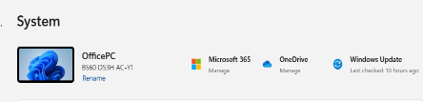

Click on the OneDrive icon shown at the top of the system folder, and you will see the folders on your system are backed up (synced) on OneDrive:

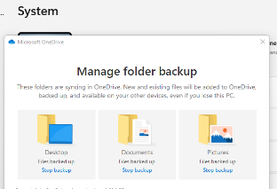

Microsoft Account

OneDrive requires a Microsoft Account. You already have a Microsoft account if you use other Microsoft features, such as Skype or the Microsoft Store. Microsoft strongly encourages Windows users to create a Microsoft account if they don’t already have one, starting when a Windows 11 system is first configured. If a user does not have a Microsoft account, one can be created anytime at the Microsoft website.

Levels of OneDrive storage

Different storage levels and other features are available for a Microsoft account. The basic free program provides a minimum of 5GB OneDrive storage. Individuals qualify for additional free storage based on the length of time they have had a Microsoft account or on the length of time they have used a Microsoft email address (Outlook, Hotmail, or Live.com). For example, I have had a Hotmail account for many years and get 15 GB of free OneDrive storage due to “loyalty bonuses.”

For $1.99 per month, you can get 100GB of storage. Microsoft 365 Personal subscriptions ($6.99/month, $69.99 a year) provide a massive1TB (1024 GB) of OneDrive online storage. Microsoft 365 Family subscriptions are $99.99 per year and $9.99 per month. They provide 1TB of OneDrive space for up to six users.

Do I really need a Microsoft account?

A Microsoft account is required to install and activate Office versions 2013 or later and Microsoft 365 for home use. You might already have a Microsoft account if you use a service like Outlook.com, OneDrive, Xbox Live, or Skype; or if you purchased Office from the online Microsoft Store. If you have no interest in OneDrive, Skype, Microsoft mail, or any of the many applications available from the Microsoft Store, you don’t need a Microsoft account.

Conclusions and Recommendations

Microsoft has evolved OneDrive into a reliable and useful service that gives you a minimum of 5GB of cloud storage for free. Over time free OneDrive cloud will grow to 15GB. Users should strongly consider using at least the free storage furnished by Microsoft to back up vital documents and pictures or any files they might need to access from any device on any internet connection in the world.

